Java Swing Labs

1. Write the Java Swing code necessary to produce the following screen (You ‘may’ need a ‘J**FlowPane’** Layout manager. You can use any Layout manager you want.**) :**

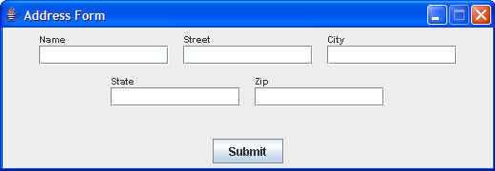

Add an appropriate EventHandler so that, when a user clicks the Submit button…

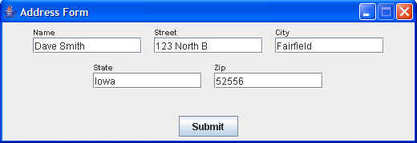

the data that has been entered into the GUI fields is output to the console in the following format:

Dave Smith

123 North B

Fairfield, Iowa 52556

2. Write the Java Swing code necessary to create the following screen:

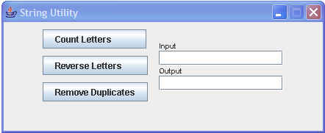

Create the necessary EventHandler so that, when Count Letters is clicked, the number of characters in the Input field is placed in the Output field,

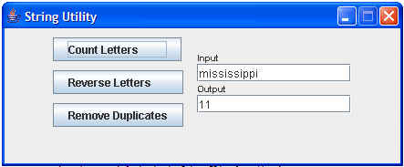

and, when Reverse Letters is clicked, the letters in the input area are reversed and placed in the output area,

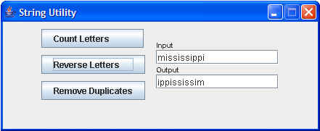

and, when the Remove Duplicates is clicked, the duplicate letters are removed and the result is placed in the output area.

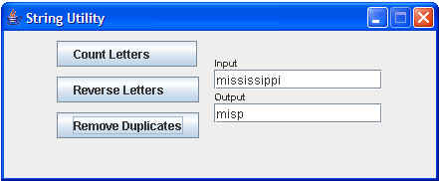

*********************************************************************

3a) Add a JMenu (called myMenu), JMenuItems (make up three names for three JMenuItems inside myMenu), and a JMenuBar to your program. Look at these classes on the Oracle Java API site. If someone clicks on a JMenuItem, print out a message displaying WHICH ONE OF THE THREE was clicked on.

***********************************************************************

More labs are here for the second part of the GUI lesson.

4) Write a complete program that creates a JCheckBox, with a list of sports. The user will check all of the sports that they play. The sports in the list are baseball, soccer, basketball, and track running. Use nested panels similar to the code we looked at in class, with the sports in the center, and an Okay button on the bottom. **Test this program very thoroughly**!

5) Write a complete program that creates a JComboBox , with a list of sports. The user will check their favorite sport. Output their favorite sport to the console. The sports in the list are baseball, soccer, basketball, and track running. Use nested panels similar to the code we looked at in class, with the sports in the center, and an Okay button on the bottom. Test this program very thoroughly!

**Level 3 : 6**) Run the JSplitPane code we looked at in class. Research the JSplitPane class on the Oracle Java API, and make some changes to the code that you just ran. Document the changes you made at the beginning of the program.

************************************************************************

**Below this line are ALL Extra Credit (XC) Labs**

**Extra Credit 1a)** : Look at the programs we looked at in class relating to Mouse Events. Study and understand the code. Create your own changes to the code, so that you can work with these Mouse Events. Document the changes you made at the beginning of your program.

**Extra Credit 1b)** : Study the SketchPad code. Create some output on the console, when MouseEvents happen.

**XC2** : For the School lab from day one, create a GUI interface using Swing.

**XC3 :** For the School lab from day one, create a GUI interface using Swing, with a menu that gives the user choices with different menu items.

Hint : Look at JMenu and JMenuItem on the Oracle Java API. It has code you can use.

You will also need a JMenuBar.

**XC4 :** Experiment with different Layout Managers.